UNIT-I

Procedural Programming vs Object-Oriented Programming

Procedural Oriented Programming | Object-Oriented Programming
In procedural programming, the program is divided into small parts called functions. | In object-oriented programming, the program is divided into small parts called objects.
Procedural programming follows a top-down approach. | Object-oriented programming follows a bottom-up approach.
There is no access specifier in procedural programming. | Object-oriented programming has access specifiers like private, public, protected, etc.
Adding new data and functions is not easy. | Adding new data and function is easy.
Procedural programming does not have any proper way of hiding data so it is less secure. | Object-oriented programming provides data hiding so it is more secure.
In procedural programming, overloading is not possible. | Overloading is possible in object-oriented programming.
In procedural programming, there is no concept of data hiding and inheritance. | In object-oriented programming, the concept of data hiding and inheritance is used.
In procedural programming, the function is more important than the data. | In object-oriented programming, data is more important than function.
Procedural programming is based on the unreal world. | Object-oriented programming is based on the real world.
Procedural programming is used for designing medium-sized programs. | Object-oriented programming is used for designing large and complex programs.
Procedural programming uses the concept of procedure abstraction. | Object-oriented programming uses the concept of data abstraction.
Code reusability absent in procedural programming, | Code reusability present in object-oriented programming.
Examples: C, FORTRAN, Pascal, Basic, etc. | Examples: C++, Java, Python, C#, etc.

Key Features of OOPs in Java:

- Structures code into logical units (classes and objects)
- Keeps related data and methods together (encapsulation)
- Makes code modular, reusable and scalable
- Prevents unauthorized access to data
- Follows the DRY (Don’t Repeat Yourself) principle

Characteristics of an OOP(Object Oriented Programming)

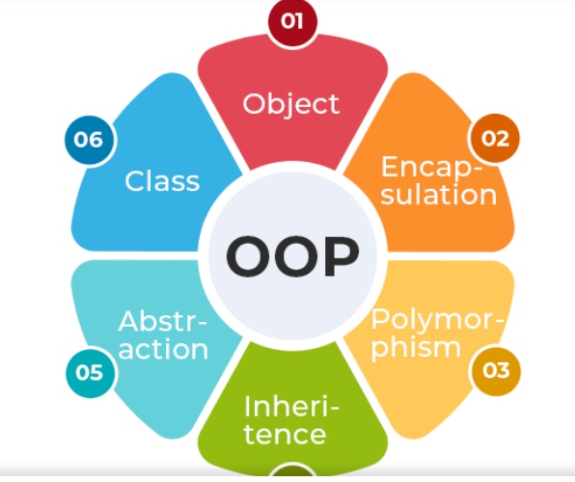

1. Class
A Class is a user-defined blueprint or prototype from which objects are created. It represents the set of properties or methods that are common to all objects of one type. Using classes, you can create multiple objects with the same behavior instead of writing their code multiple times. In general, class declarations can include these components in order:
- Modifiers: A class can be public or have default access (Refer to this for details).
- Class name: The class name should begin with the initial letter capitalized by convention.
- Body: The class body is surrounded by braces, { }.

2. Object
An Object is a basic unit of Object-Oriented Programming that represents real-life entities. A typical Java program creates many objects, which as you know, interact by invoking methods. The objects are what perform your code, they are the part of your code visible to the viewer/user. An object mainly consists of:
- State: It is represented by the attributes of an object. It also reflects the properties of an object.
- Behavior: It is represented by the methods of an object. It also reflects the response of an object to other objects.
- Identity: It is a unique name given to an object that enables it to interact with other objects.
- Method: A method is a collection of statements that perform some specific task and return the result to the caller.

Example:
public class Employee {
// Instance variables (non-static)
private String name;
private float salary;
​
// Constructor
public Employee(String name, float salary) {
this.name = name;
this.salary = salary;
}
​
// getters method
public String getName() { return name; }
public float getSalary() { return salary; }
​
// setters method
public void setName(String name) { this.name = name; }
public void setSalary(float salary) { this.salary = salary; }
​
// Instance method
public void displayDetails() {
System.out.println("Employee: " + name);
System.out.println("Salary: " + salary);
}
​
public static void main(String[] args) {
Employee emp = new Employee("Geek", 10000.0f);
emp.displayDetails();
}
}
Output
Employee: Geek
Salary: 10000.0
Note: For more information, please refer to the article - Classes and Object.

3. Abstraction
Abstraction in Java is the process of hiding the implementation details and only showing the essential details or features to the user. It allows to focus on what an object does rather than how it does it. The unnecessary details are not displayed to the user.
Note: In Java, abstraction is achieved by interfaces and abstract classes. We can achieve 100% abstraction using interfaces.
Example:
abstract class Vehicle {
// Abstract methods (what it can do)
abstract void accelerate();
abstract void brake();

// Concrete method (common to all vehicles)
void startEngine() {
System.out.println("Engine started!");
}
}
​
// Concrete implementation (hidden details)
class Car extends Vehicle {
@Override
void accelerate() {
System.out.println("Car: Pressing gas pedal...");
// Hidden complex logic: fuel injection, gear shifting, etc.
}

@Override
void brake() {
System.out.println("Car: Applying brakes...");
// Hidden logic: hydraulic pressure, brake pads, etc.
}
}
​
public class Main {
public static void main(String[] args) {
Vehicle myCar = new Car();
myCar.startEngine();
myCar.accelerate();
myCar.brake();
}
}
Note: To learn more about the Abstraction refer to the Abstraction in Java article

4. Encapsulation
Encapsulation is defined as the process of wrapping data and the methods into a single unit, typically a class. It is the mechanism that binds together the code and the data. It manipulates. Another way to think about encapsulation is that it is a protective shield that prevents the data from being accessed by the code outside this shield.
- Technically, in encapsulation, the variables or the data in a class is hidden from any other class and can be accessed only through any member function of the class in which they are declared.
- In encapsulation, the data in a class is hidden from other classes, which is similar to what data-hiding does. So, the terms "encapsulation" and "data-hiding" are used interchangeably.
- Encapsulation can be achieved by declaring all the variables in a class as private and writing public methods in the class to set and get the values of the variables.
Encapsulation
Example:
class Employee {
// Private fields (encapsulated data)
private int id;
private String name;
​
// Setter methods
public void setId(int id) {
this.id = id;
}
​
public void setName(String name) {
this.name = name;
}
​
// Getter methods
public int getId() {
return id;
}
​
public String getName() {
return name;
}
}
​
public class Main {
public static void main(String[] args) {
Employee emp = new Employee();

// Using setters
emp.setId(101);
emp.setName("Geek");
​
// Using getters
System.out.println("Employee ID: " + emp.getId());
System.out.println("Employee Name: " + emp.getName());
}
}
Output
Employee ID: 101
Employee Name: Geek
Note: To learn more about topic refer to Encapsulation in Java article.

5. Inheritance
Inheritance is an important pillar of OOP (Object Oriented Programming). It is the mechanism in Java by which one class is allowed to inherit the features (fields and methods) of another class. We are achieving inheritance by using extends keyword. Inheritance is also known as "is-a" relationship.
Example: Dog, Cat, Cow can be Derived Class of Animal Base Class.
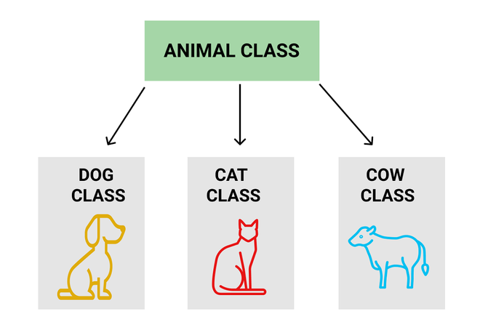Inheritance
Let us discuss some frequently used important terminologies:
- Superclass: The class whose features are inherited is known as superclass (also known as base or parent class).
- Subclass: The class that inherits the other class is known as subclass (also known as derived or extended or child class). The subclass can add its own fields and methods in addition to the superclass fields and methods.
- Reusability: Inheritance supports the concept of "reusability", i.e. when we want to create a new class and there is already a class that includes some of the code that we want, we can derive our new class from the existing class. By doing this, we are reusing the fields and methods of the existing class.
Example:
// Superclass (Parent)
class Animal {
void eat() {
System.out.println("Animal is eating...");
}
​
void sleep() {
System.out.println("Animal is sleeping...");
}
}
​
// Subclass (Child) - Inherits from Animal
class Dog extends Animal {
void bark() {
System.out.println("Dog is barking!");
}
}
​
public class Main {
public static void main(String[] args) {
Dog myDog = new Dog();
​
// Inherited methods (from Animal)
myDog.eat();
myDog.sleep();
​
// Child class method
myDog.bark();
}
}
Output
Animal is eating...
Animal is sleeping...
Dog is barking!
Note: To learn more about topic refer to Inheritance in Java article.

6. Polymorphism
The word polymorphism means having many forms, and it comes from the Greek words poly (many) and morph (forms), this means one entity can take many forms. In Java, polymorphism allows the same method or object to behave differently based on the context, specially on the project's actual runtime class.
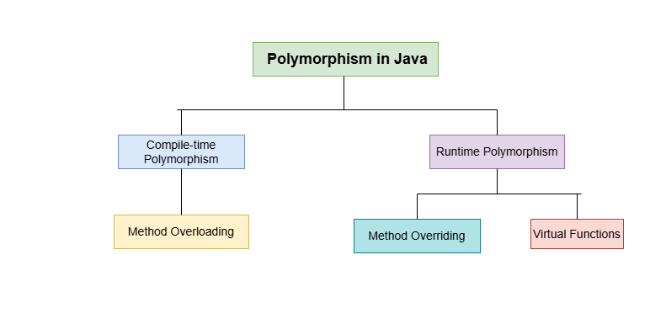Polymorphism

Types of Polymorphism
Polymorphism in Java is mainly of 2 types as mentioned below:
- Method Overloading
- Method Overriding

Method Overloading and Method Overriding
1. Method Overloading: Also, known as compile-time polymorphism, is the concept of Polymorphism where more than one method share the same name with different signature(Parameters) in a class. The return type of these methods can or cannot be same.
2. Method Overriding: Also, known as run-time polymorphism, is the concept of Polymorphism where method in the child class has the same name, return-type and parameters as in parent class. The child class provides the implementation in the method already written.
Below is the implementation of both the concepts:
// Parent Class
class Parent {
// Overloaded method (compile-time polymorphism)
public void func() {
System.out.println("Parent.func()");
}
​
// Overloaded method (same name, different parameter)
public void func(int a) {
System.out.println("Parent.func(int): " + a);
}
}
​
// Child Class
class Child extends Parent {
// Overrides Parent.func(int) (runtime polymorphism)
@Override
public void func(int a) {
System.out.println("Child.func(int): " + a);
}
}
​
public class Main {
public static void main(String[] args) {
Parent parent = new Parent();
Child child = new Child();
// Dynamic dispatch
Parent polymorphicObj = new Child();
​
// Method Overloading (compile-time)
parent.func();
parent.func(10);
​
// Method Overriding (runtime)
child.func(20);
​
// Polymorphism in action
polymorphicObj.func(30);
}
}
Output
Parent.func()
Parent.func(int): 10
Child.func(int): 20
Child.func(int): 30

Advantage of OOPs over Procedure-Oriented Programming Language
Object-oriented programming (OOP) offers several key advantages over procedural programming:
- By using objects and classes, you can create reusable components, leading to less duplication and more efficient development.
- It provides a clear and logical structure, making the code easier to understand, maintain, and debug.
- OOP supports the DRY (Don't Repeat Yourself) principle.This principle encourages minimizing code repetition, leading to cleaner, more maintainable code. Common functionalities are placed in a single location and reused, reducing redundancy.
- By reusing existing code and creating modular components, OOP allows for quicker and more efficient application development

Disadvantages of OOPs
- OOP has concepts like classes, objects, inheritance etc. For beginners, this can be confusing and takes time to learn.
- If we write a small program, using OOP can feel too heavy. We might have to write more code than needed just to follow the OOP structure.
- The code is divided into different classes and layers, so in this, finding and fixing bugs can sometimes take more time.
- OOP creates a lot of objects, so it can use more memory compared to simple programs written in a procedural way.

Access Modifiers in Java

Types of Access Modifiers
There are 4 types of access modifiers available in Java:
- Default - No keyword required
- Private
- Protected
- Public

Algorithm to Use Access Modifier in Java

Here's a basic algorithm for using access modifiers in Java:
1. Define a class: Create a class to represent the object you want to manage.
2. Define instance variables: Inside the class, define variables for the data you want to manage.
3. Set an access modifier:
- Use private for variables only accessible within the class.
- Use protected for variables accessible within the class and its subclasses.
- Use public for variables accessible from anywhere.
4. Use getter and setter methods: To access or modify variables, use getter (accessor) and setter (mutator) methods, even for public variables, to maintain encapsulation.

1. Default Access Modifier
When no access modifier is specified for a class, method, or data member, it is said to have the default access modifier by default. This means only classes within the same package can access it.
Example 1: Demonstrating Default Access Modifier Within the Same Package
In this example, we will create two packages and the classes in the packages will be having the default access modifiers and we will try to access a class from one package from a class of the second package.
Geeks.java
// default access modifier
package p1;

// Class Geek is having
// Default access modifier
class Geek
{
void display()
{
System.out.println("Hello World!");
}
}
GeeksNew.java:
// error while using class from different
// package with default modifier
package p2;
import p1.*; // importing package p1

// This class is having
// default access modifier
class GeekNew {
public static void main(String args[]) {

// Accessing class Geek from package p1
Geek o = new Geek();

o.display();
}
}
Explanation: In this example, the program will show the compile-time error when we try to access a default modifier class from a different package.

2. Private Access Modifier
The private access modifier is specified using the keyword private. The methods or data members declared as private are accessible only within the class in which they are declared.
- Any other class of the same package will not be able to access these members.
- Top-level classes or interfaces can not be declared as private because, private means "only visible within the enclosing class". Protected means "only visible within the enclosing class and any subclasses".
These modifiers in terms of application to classes, apply only to nested classes and not on top-level classes.
Example: In this example, we will create two classes A and B within the same package p1. We will declare a method in class A as private and try to access this method from class B and see the result.
// Error while using class from different package with
// private access modifier
package p1;

// Class A
class A {
private void display() {
System.out.println("GeeksforGeeks");
}
}

// Class B
class B {
public static void main(String args[]) {
A obj = new A();

// Trying to access private method
// of another class
obj.display();
}
}
Explanation: The above code will show a compile-time error when trying to access a private method from class B, even within the same package.

3. Protected Access Modifier
The protected access modifier is specified using the keyword protected. The methods or data members declared as protected are accessible within the same package or subclasses in different packages.
Example 1: In this example, we will create two packages p1 and p2. Class A in p1 is made public, to access it in p2. The method display in class A is protected and class B is inherited from class A and this protected method is then accessed by creating an object of class B.
// protected access modifier
package p1;

// Class A
public class A {
protected void display() {
System.out.println("GeeksforGeeks");
}
}
So, it demonstrates that a protected method is accessible within the same package.
Example 2: In this example, we will create two packages, p1 and p2. Class A in p1 has a protected method display. Class B in p2 extends A and accesses the protected method through inheritance by creating an object of class B.
// protected modifier
package p2;

// importing all classes
// in package p1
import p1.*;

// Class B is subclass of A
class B extends A {
public static void main(String args[]) {
B obj = new B();
obj.display();
}
}
Explanation: The above example demonstrates that a protected method is accessible in a subclass from a different package using inheritance.

4. Public Access Modifier
The public access modifier is specified using the keyword public.
- The public access modifier has the widest scope among all other access modifiers.
- Classes, methods, or data members that are declared as public are accessible from everywhere in the program. There is no restriction on the scope of public data members.
Example 1: Here, the code shows that a public method is accessible within the same package.
// public modifier
package p1;

public class A {

public void display() {
System.out.println("GeeksforGeeks");
}
}
Example 2: Here, the example shows that a public method is accessible across packages.
// public access modifier
package p2;

import p1.*;

class B {
public static void main(String args[]) {

A obj = new A();
obj.display();
}
}

Java Constructors
In Java, constructors play an important role in object creation. A constructor is a special block of code that is called when an object is created. Its main job is to initialize the object, to set up its internal state, or to assign default values to its attributes. This process happens automatically when we use the "new" keyword to create an object.
Characteristics of Constructors:
- Same Name as the Class: A constructor has the same name as the class in which it is defined.
- No Return Type: Constructors do not have any return type, not even void. The main purpose of a constructor is to initialize the object, not to return a value.
- Automatically Called on Object Creation: When an object of a class is created, the constructor is called automatically to initialize the object’s attributes.
- Used to Set Initial Values for Object Attributes: Constructors are primarily used to set the initial state or values of an object’s attributes when it is created.
Now, let us look at a simple example to understand how a constructor works in Java.
Example: This program demonstrates how a constructor is automatically called when an object is created in Java.
// Java Program to demonstrate
// Constructor usage
import java.io.*;
​
// Driver Class
class Geeks {

// Constructor
Geeks()
{
super();
System.out.println("Constructor Called");
}
​
// main function
public static void main(String[] args)
{
Geeks geek = new Geeks();
}
}
Output
Constructor Called
Note: It is not necessary to write a constructor for a class. It is because the Java compiler creates a default constructor (constructor with no arguments) if your class doesn't have any.

Constructor vs Method in Java
The below table demonstrates the key difference between Java Constructor and Java Methods.
Features | Constructor | Method
Name | Constructors must have the same name as the class name | Methods can have any valid name
Return Type | Constructors do not return any type | Methods have the return type or void if does not return any value.
Invocation | Constructors are called automatically with new keyword | Methods are called explicitly
Purpose | Constructors are used to initialize objects | Methods are used to perform operations

Java Destructor
In programming, a destructor is a method called when an object is destroyed, typically to release resources like memory, file handles, or network connections. In languages like C++, destructors are explicitly used to manage resource cleanup. However, Java takes a different approach due to its automatic memory management system powered by garbage collection.

Destructor in Java
Java does not have explicit destructors like C++ because the garbage collector automatically manages Java’s memory. Garbage collection tracks objects in memory, and when they are no longer referenced, it automatically reclaims the memory.
Although Java does not provide destructors, it used to have a method called finalize() that could be overridden to define cleanup operations before an object is garbage collected. The finalize() method has been deprecated since Java 9 and removed in Java 18 due to its unpredictability and performance overhead. Instead, modern Java programs rely on other mechanisms for resource management, such as AutoCloseable and try-with-resources.

Advantages of Destructors
- Automatic Resource Management: By automating the process of freeing up memory and other resources, Java's garbage collector lowers the possibility of memory leaks and improper resource management.
- Simplifies Programming: By eliminating the need for developers to manually monitor and release memory, programming becomes simpler and less prone to error.
- Enhances Performance: By effectively handling memory allocation and deallocation, automated memory management can aid in performance optimization.

Memory Management in Java
- Java’s garbage collector automatically manages the lifecycle of objects.
- When no references point to an object, it becomes eligible for garbage collection.
- The garbage collector reclaims memory at its discretion, making memory management automated and simplifying development.

Why Java Doesn’t Need Destructors?
In languages like C++, destructors are essential because programmers manually manage memory allocation and deallocation. In contrast, Java developers don’t have to worry about this due to its automatic garbage collection system. Instead of destructors, developers in Java can handle resource management using the try-with-resources statement and AutoCloseable interface, ensuring resources like files, database connections, or sockets are properly closed.

Alternatives to Finalization in Java
- AutoCloseable and try-with-resources:
  - This is the preferred method for managing resources that require cleanup, such as file streams, database connections, or network sockets.
  - The try-with-resources statement ensures that resources are automatically closed after usage, without relying on the garbage collector's unpredictable behavior.
- java.lang.ref.Cleaner Class:
  - For advanced cleanup tasks where AutoCloseable is not sufficient, Java 9 introduced the Cleaner class as a replacement for finalize().
  - Cleaner allows you to register cleanup actions that are invoked once the object becomes unreachable, without the issues associated with finalize().

Example Using AutoCloseable and try-with-resources
import java.io.*;
​
public class Resource implements AutoCloseable {
​
public Resource() {
System.out.println("Resource acquired.");
}
​
@Override
public void close() {
System.out.println("Resource released.");
}
​
public static void main(String[] args) {
try (Resource resource = new Resource()) {
System.out.println("Using the resource.");
} // close() is automatically called here
System.out.println("End of program.");
}
}
Output
Resource acquired.
Using the resource.
Resource released.
End of program.

Java Exception Handling
Exception handling in Java is an effective mechanism for managing runtime errors to ensure the application's regular flow is maintained. Some Common examples of exceptions include ClassNotFoundException, IOException, SQLException, RemoteException, etc. By handling these exceptions, Java enables developers to create robust and fault-tolerant applications.
Example: Showing an arithmetic exception, or we can say a divide by zero exception.
import java.io.*;
​
class Geeks {
public static void main(String[] args)
{
int n = 10;
int m = 0;
​
int ans = n / m;
​
System.out.println("Answer: " + ans);
}
}
Output:
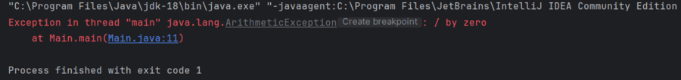
Note: When an exception occurs and is not handled, the program terminates abruptly and the code after it, will never execute.

Example: The below Java program modifies the previous example to handle an ArithmeticException using try-catch, and finally blocks and keeps the program running.
// Java program to demonstrates handling
// the exception using try-catch block
import java.io.*;
​
class Geeks {
public static void main(String[] args)
{
int n = 10;
int m = 0;
​
try {

// Code that may throw an exception
int ans = n / m;
System.out.println("Answer: " + ans);
}
catch (ArithmeticException e) {

// Handling the exception
System.out.println(
"Error: Division by zero is not allowed!");
}
finally {
System.out.println(
"Program continues after handling the exception.");
}
}
}
Output
Error: Division by zero is not allowed!
Program continues after handling the exception.
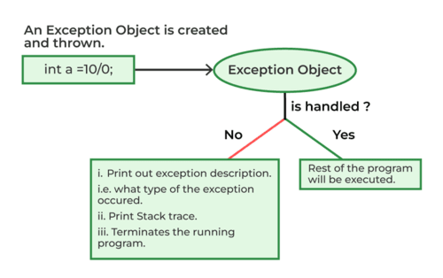workFlow

Java Exception Hierarchy
In Java, all exceptions and errors are subclasses of the Throwable class. It has two main branches
- Exception.
- Error

